**IFT 466 Advanced Computer Networks**

**Lab 33  
  
Point to Point Protocol (PPP)**

After you complete each step, put a ‘√’ or ‘x’ in the completed box

Point-to-Point Protocol (PPP) is a data link layer (OSI layer 2) protocol.

PPP’s purpose in life is to establish connections between nodes over a physical layer.

**Objectives**

Explore how PPP can operate to provide Ethernet connectivity in non-Ethernet based network.

**Part 1: Setup and configuration of topology**

1. Setup the following topology with the address scheme provided

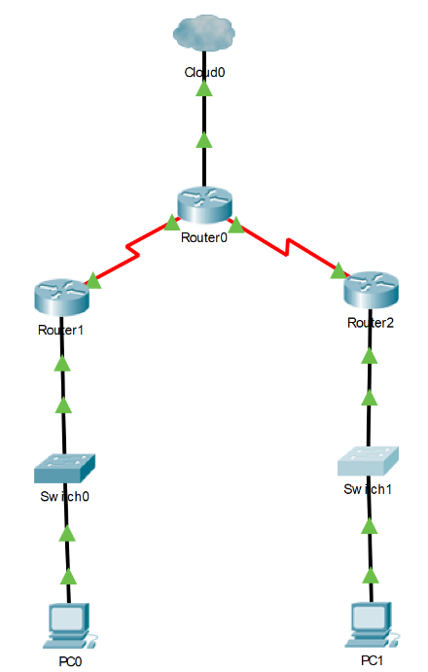

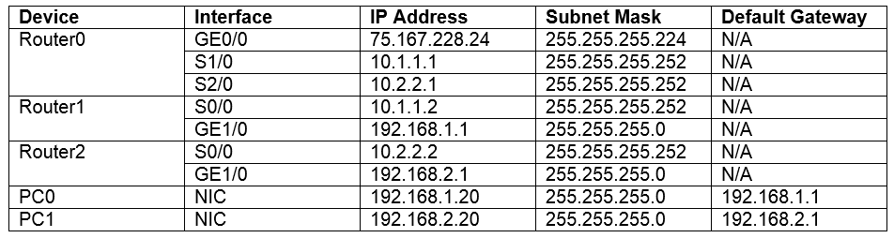



✓

1. ****Make sure that every node on the network can communicate with every other node (RIP, OSPF, or static routes are all okay).

✓

**Part 2: Configure PPP**

1. ****On Router 1 and Router 2 check the serial interfaces with `show interfaces serial 0/0`.   
     
   Both serial connections should say “Encapsulation HDLC” as that is the default encapsulation method on Cisco serial connection.   
     
    ✓
2. We’re going to replace HDLC encapsulation with PPP encapsulation.   
     
   In order to see the effects of the configuration we’re going to turn on debugging to see more information while we configure PPP.

On both Router0 and Router1 use both of these commands from privilege exec mode

debug ppp negotiation

****debug ppp packet

✓

1. Now we will see additional information when ppp is active and functioning.

Once again on both Router 0 and Router 1 use the following command starting from correct serial interfaces on the same link.

encapsulation ppp

****You will see the entire process the router goes through in order to establish a link utilizing the PPP protocol at this point.

✓

1. Let’s create a similar PPP connection on the other link between Router 0 and Router 2. From their respective serial interfaces run the following commands from privilege exec mode.

debug ppp negotiation

debug ppp packet

debug ppp authentication

username <opposite routers hostname (Router0 or Router 2)> password cisco

int serial 0/0

encapsulation ppp

ppp authentication chap

 ✓

1. Thus far we’ve created a link that simply uses PPP and one that uses PPP with a password.   
     
   If we go to Router2 and change the password to something else, we’ll see that the pings between the computers will now fail even though the serial connection remains “active”.

username Router0 password juniper

This is the basis of how ISPs can limit access to their network through the use of encrypted CHAP passwords.



✓